**Advance Excel Assignment 5**

***1. How many types of conditions are available in conditional formatting on Excel?***

There are five different types of conditional formatting in Excel. These types are- Highlight Cells Rules, Top and Bottom Rules, Data Bars, Color Scales, and Icon Sets. Under these types, there are some sub-types.

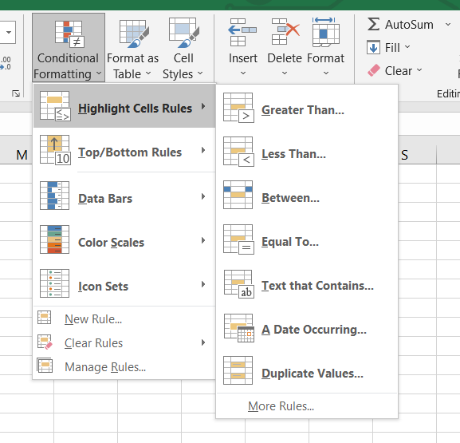

**1. Highlight Cells Rules**

The first type of the five types of conditional formatting in Excel is the Highlight Cells Rules. Under this type, we will give some specific conditions, and the presentation of the cells will change upon these conditions.

1.1 Cell Value Is Greater Than Particular Value

Here we will format the cells based on the greater than condition. We will set a particular value and will see how many cell values are greater than that value. To do this, follow the following steps.

1.2 Cell Value Is Lesser Than Particular Value

This section is the reverse topic of the previous one. Here, we will highlight the cells that have lesser values than a particular value.

1.3 Cell Values Between Two Values

Our third highlighting criterion will be cell values that fall between two given values.

For example, if we have to highlight the cells that are between 200 and 600, we will choose the Cell Values Between Two Values conditional formating.

1.4 Cell Value Is Equal to Particular Value

The goal of this section is to highlight certain cells that are equal to a particular value.

1.5 Cell Containing Particular Text

All our earlier conditions are based on numbers or values. But in this section, we can find a particular text using conditional formatting.

1.6 Cell Containing Particular Dates

In this type, we can apply some regarding dates in the data set.

1.7 Duplicate Cell Values

The last condition of the Highlight Cells Rules deals with finding duplicate values from the data set.

**2. Top and Bottom Rules**

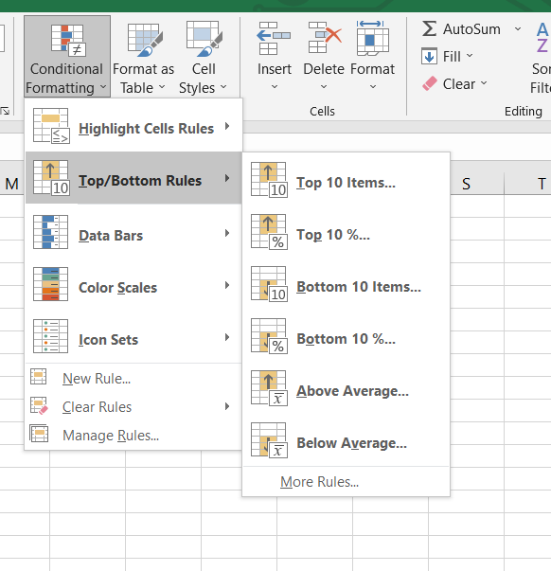

The Top and Bottom Rules are the second type of Conditional Formatting in Excel. If you want to highlight the highest or lowest value from your data set or want to figure out the top or bottom percentage of data, then this type is the best choice for doing so.

2.1 Top 10 items..

Sometimes, We want to show the topmost values in their given data for analysis. In this option we can choose top 10 items . This condition will highlight the top 10 values from our data set. we can also edit the formatting and choose top 5 items.

2.2 Top 10% Values from Data Set

If we want to highlight how many values from your data set belong to the top 10 percent of the whole data set, then we can apply this condition. This will highlight condition to see cells that fall in the top 10% of the total value.

2.3 Bottom Values from Data Set

For the third criterion of this type, we can highlight the bottommost values of a data set.

2.4 Bottom 10% Values from Data Set

In section 2.2, we have seen the use of the Top 10% Value condition on a given data set. Here, we will show the reverse of this condition. This option will choose Bottom 10%.

2.6 Below Average Values of Data Set

We can find the below-average values of a data set, which is the last condition of the Top/Bottom Rules. The data that fall under the applied condition will be highlighted from the data set.

**3. Data Bars**

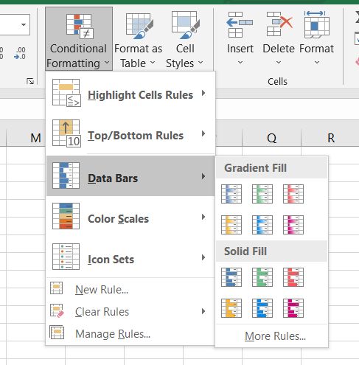

This is the third of the five types of conditional formatting in Excel. If you want to compare the numerical values in your data set, then this condition will be an ideal choice. Based on the cell values, this condition will create bars that will portray both positive and negative values.

**4. Color Scales**

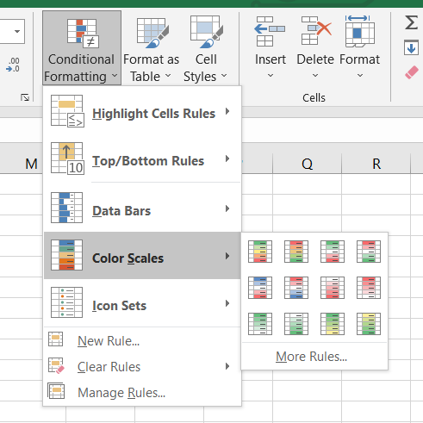

The fourth of the five types of conditional formatting is Color Scales. It displays the disposal of data in the data set. We can mix two colors or three colors on the scale. The topmost color will represent the greater values, the middle scale will represent the average values, and the bottom color scale will represent the lower values in a data set.

From the more rules, we can set more conditions .

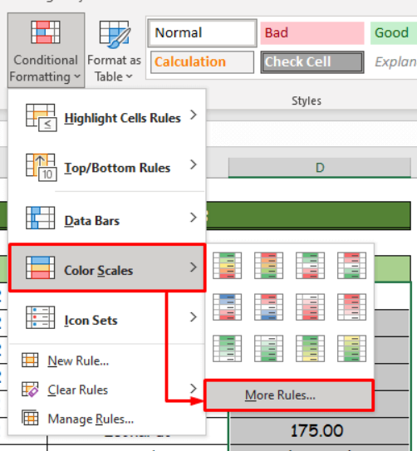

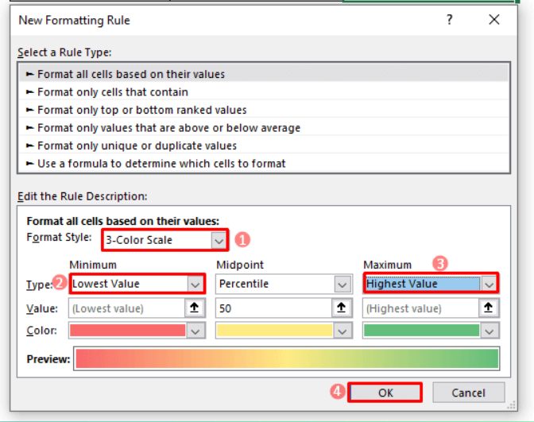

**5. Icon Sets**

The last type of the five types of conditional formatting is the Icon Sets. This type also works as in the previous two examples. This condition implements icons in the selected cell range based on their cell values.

Here , the red icons represent the lower values, the yellow icons represent the middle values, and the green icons represent the higher values of the data set.

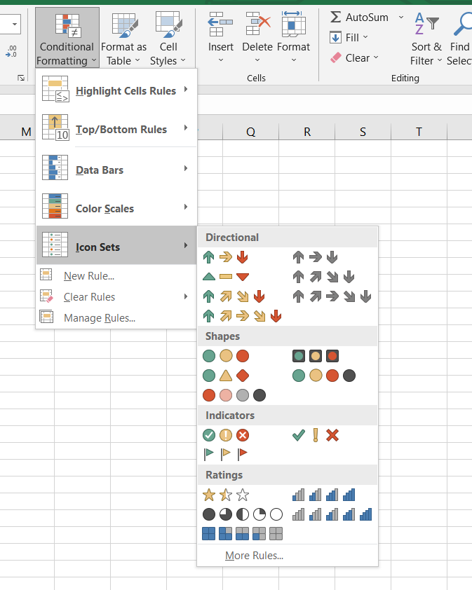

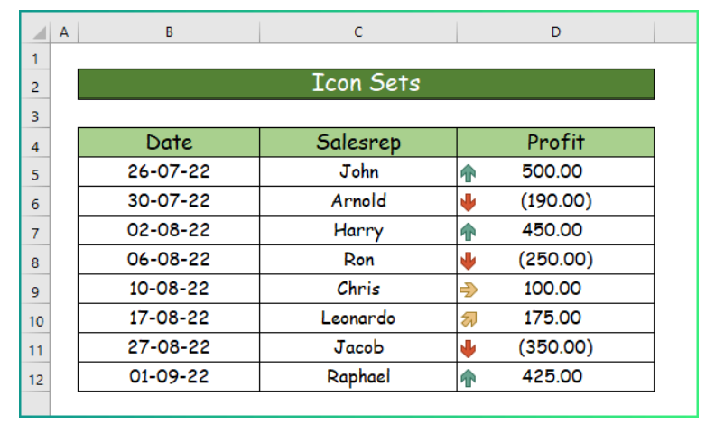

***2. How to insert border in Excel with Format Cells dialog?***

The Format Cells dialog is the most effective method of adding borders in Excel. It gives us easy access to all the settings including the line color and thickness as well as a nice diagram preview.

To insert a border via the Format Cells dialog, this is what we need to do:

1. Select one or more cells to which we'd like to add borders.
2. Open the Format Cells dialog box by doing one of the following:
3. Click the down arrow next to the Borders button, and then click More Borders at the bottom of the drop-down list.
4. Right click the selected cells and choose Format Cells… from the context menu.
5. Press Ctrl+1 shortcut.
6. In the Format Cells dialog box, switch to the Border tab and choose the line style and color first. And then, either use Presets to add the outside or inside borders or construct the desired border by selecting individual elements such as border top, bottom, right or left. The preview diagram will reflect the changes immediately.
7. When done, click OK.

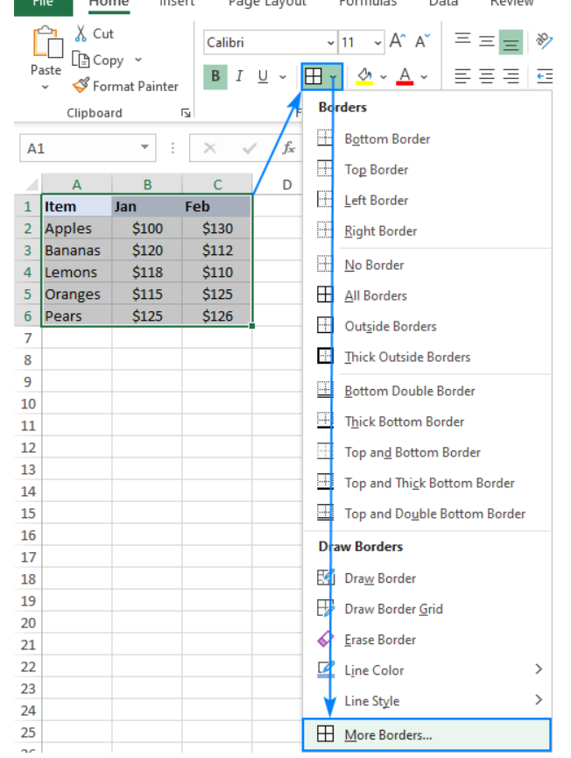

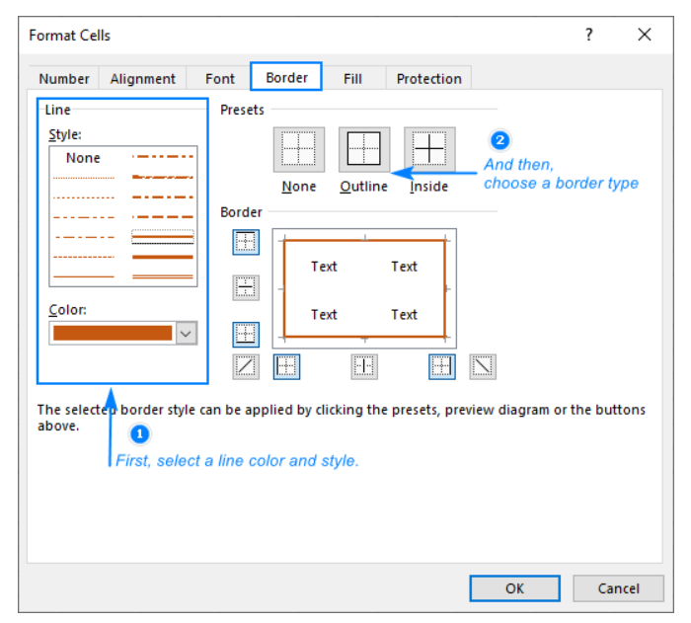

***3. How to Format Numbers as Currency in Excel?***

To show numbers as currency, you can apply either the Currency format or the Accounting format.

1. Select the cells that you want to format and then, in the Number group on the Home tab, click the down arrow in the Number Format box.
2. Choose either Currency or Accounting.

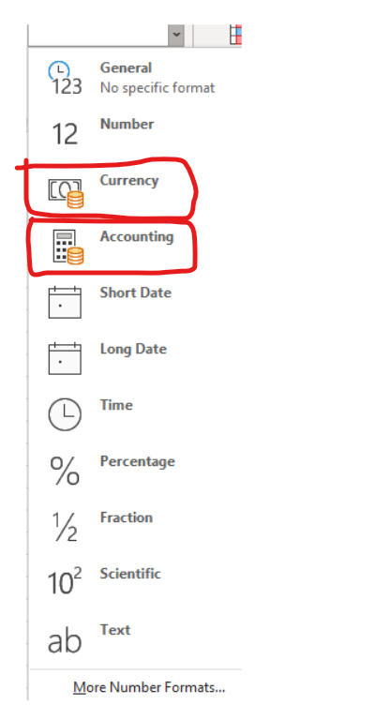

**Currency format :-**

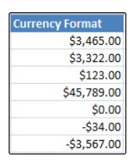

**Accounting format :-**

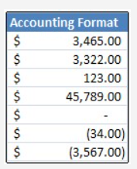

***4. What are the steps to format numbers in Excel with the Percent style?***

To quickly apply percentage formatting to selected cells, click Percent Style in the Number group on the Home tab, or press Ctrl+Shift+%. If you want more control over the format, or you want to change other aspects of formatting for your selection, you can follow these steps.

1. On the Home tab, in the Number group, click the icon next to Number to display the Format Cells dialog box.

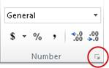

1. In the Format Cells dialog box, in the Category list, click Percentage.

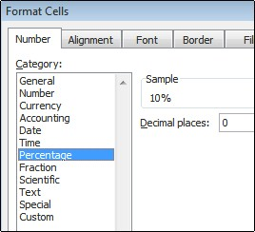

1. In the Decimal places box, enter the number of decimal places that you want to display. For example, if you want to see 10% instead of 10.00%, enter 0 in the Decimal places box.

***5. What is a shortcut to merge two or more cells in excel?***

Merge cells: To merge two or more cells, highlight them and then press the following keys at the same time: ALT H+M+M.

Merge and center cells: If you would like to merge cells and center your text at the same time, you can highlight the cells and press these keys: ALT H+M+C.

Merge across cells: To merge across cells in a single row, highlight the cells and use this keyboard shortcut: ALT H+M+C.

***6. How do you use text commands in Excel?***

TEXT in Excel is used to convert a numeric value to a text string in a specific format.

The syntax for the Excel TEXT function is as follows:

TEXT(value, format_text)

Where: Value - the numeric value to be converted to text. It can be a number, date, reference to a cell containing a numeric value or another function that returns a number or date.

Format_text - the format that you want to apply. It is supplied in the form of a format code enclosed in the quotation marks, e.g. "mm/dd/yy".

Generally, an Excel TEXT formula is used in the following situations:

1. To display numbers in a more readable way or in a format that makes more sense for your users.
2. To display dates in a specific format.
3. To combine numbers or dates with certain text or characters.

For example, if you want to pull the date from cell A2 and show it in another cell in the traditional date format like "January 1, 2016", you use the following Excel TEXT formula:

=TEXT(A2, "mmmm d, yyyy")

The result will look similar to this: 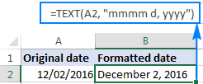

The TEXT function in Excel converts a numeric value to a text strings. Consequently, you won't be able to use the result of your Text formula in other calculations. If there's such a need, you can keep the original values (hidden or kept out of sight), and use them in other formulas.